_ CM . . . . Volume XXIV Number 40. . . .June 15, 2018
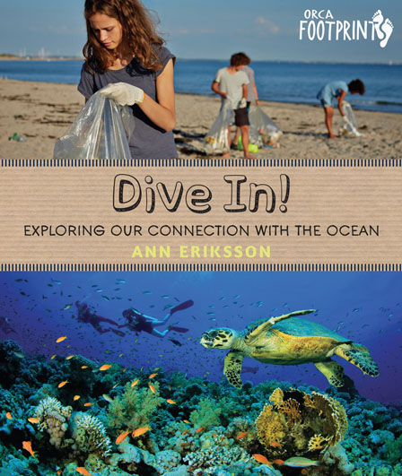 | Dive In! Exploring Our Connection with the Ocean. (Orca Footprints).  Ann Eriksson.  Victoria, BC: Orca, Oct., 2018.  48 pp., hc., pdf & epub, $19.95 (hc.).  ISBN 978-1-4598-1586-5 (hc.), ISBN 978-1-4598-1587-2 (pdf), ISBN 978-1-4598-1588-9 (epub).  Subject Headings:  Oceans-Juvenile literature.  Oceanography-Juvenile literature.  Grades 3-7 / Ages 8-12.  Review by Gillian Richardson.  **** /4  Reviewed from Advance Reading Copy.
Excerpt:
Humans have lived on Earth for the blink of an eye (only 200,00 years out of the 4.5 billion years that Earth has existed). Early on, when there weren’t many of us and we lived simply, our impact on the ocean, our ecological ocean footprint, was small. But now that there are over seven billion of us, the choices we make affect the ocean, and all life that shares the planet with us, in a big way. Many of our greatest accomplishments have had unintended consequences, or results we didn’t plan on, that have caused problems for ocean health.
For one, humans are excellent at catching fish. Trillions of wild fish are caught every year worldwide. Fish from the ocean is the main source of food for many people. But too many of us are eating too many fish, and we’re eating them faster than they can reproduce. Many are used for fertilizers or to feed farmed animals, even other fish species. Scientists who study fish and fishing say that 80 percent of marine fish species are in trouble.

It’s easy to find current books about ocean pollution and the effects of climate change. Dive In! covers some of that ground, but the specific focus is on connecting the human factor with urgent ocean issues. Beginning with her impassioned Introduction – “we are all ocean” -- author, Ann Eriksson, a biologist and self-proclaimed thalassophile (one who loves oceans) drives home the point that oceans matter to us all wherever we live on the planet. This book is a call to action, an eloquent appeal to take up the cause to improve ocean health.
The first chapter describes how “You Are Ocean”. Readers will hear that the ocean is the source of more than half of the world’s oxygen, producing it, in part, from the carbon dioxide we breathe out. Readers learn how all fresh water originates in the ocean, how it is a gigantic heat regulator and why ocean biodiversity matters. Many foods and medicines come from the ocean. It even affects our mental health.
Having established our critical need for the ocean, the author flips to the ways we’ve abused it in Chapter Two: overfishing, habitat destruction, pollution (with a strong focus on plastic and toxic chemicals), greenhouse gases creating rising temperatures. This chapter ends with the question, “But what can a kid do?”
In a word, plenty! Chapter Three offers kid-accessible, ocean-friendly solutions, such as planting trees (carbon-absorbing), insisting on sustainable seafood choices, adding ‘refuse’ (to buy plastic) to the 3 R’s, using environmentally friendly cleaning and gardening products, conserving energy. Most of these actions may be familiar to kids, but not necessarily in relation to the ocean, because if “you live far from the ocean, it’s not as easy to see the consequences of your choices on marine health”.
The final chapter talks about broader endeavors like beach cleanups, changing attitudes about litter, supporting the creation of marine protected areas, volunteering as a citizen scientist and finding ways to work for the ocean. Looking into the future on the final page, the reader is invited to imagine the ocean in 100 years….if we do nothing, or if we try to work together, following the author’s example, to create “a cherished place... for recreation and inspiration”.
A short list of print resources offers further reading, and a lengthy list of online links gives plenty of additional material to explore. The full-page Glossary defines terms given in bold in the text.
Inserts entitled “My Marine Life” pull readers into the personal life of the author. She describes discovering the wonders of scuba diving, enjoying the sailboat passed on to her by her dad, watching clam digging and the wealth of wildlife from her coastal home, kayaking for relaxation, participating in community conservation activities and drawing inspiration from marine scientist friends. All those anecdotes help readers understand and trust the relevance of ideas in Dive In!. It also helps that those ideas are presented in a conversational writing style: for instance, the reader is engaged in the explanation about oxygen by simply breathing in, holding it, breathing out. Nothing complicated, but it puts one at the center of the discussion, invited to “think about it”. “Did you know you might be eating seaweed when you eat ice cream?” is another example of involving the reader as the explanation about algin unfolds. “Ocean Facts”, small inserts, attest to the level of research with amazing statistics: “eating 83 Big Macs can produce enough carbon dioxide to melt 1 square meter of summer Arctic sea ice.” There will be an Index in the finished copy.
The photos are clear and well-labeled with numerous details not found in the main text. Some elicit surprise, like the “more boats than water” appearance of a bay in Malta, and a brilliant sculpture made from ocean trash.
Overall, Dive In! is a lively, up-to-date and thought-provoking book that should readily engage young readers and encourage them to consider their role in ocean preservation, for its health and their own. A timely read for anyone!
Highly Recommended.
Gillian Richardson is a freelance writer living in BC.
To comment on this title or this review, send mail to cm@umanitoba.ca.
© CM Association  CC BY-NC-ND  Hosted by:  University of Manitoba  ISSN 1201-9364 | This Creative Commons license allows you to download the review and share it with others as long as you credit the CM Association. You cannot change the review in any way or use it commercially.  Commercial use is available through a contract with the CM Association. This Creative Commons license allows publishers whose works are being reviewed to download and share said CM reviews provided you credit the CM Association.
Next Review | Table of Contents for This Issue - June 15, 2018.
CM Home | Back Issues | Search | CM Archive | Profiles Archive

